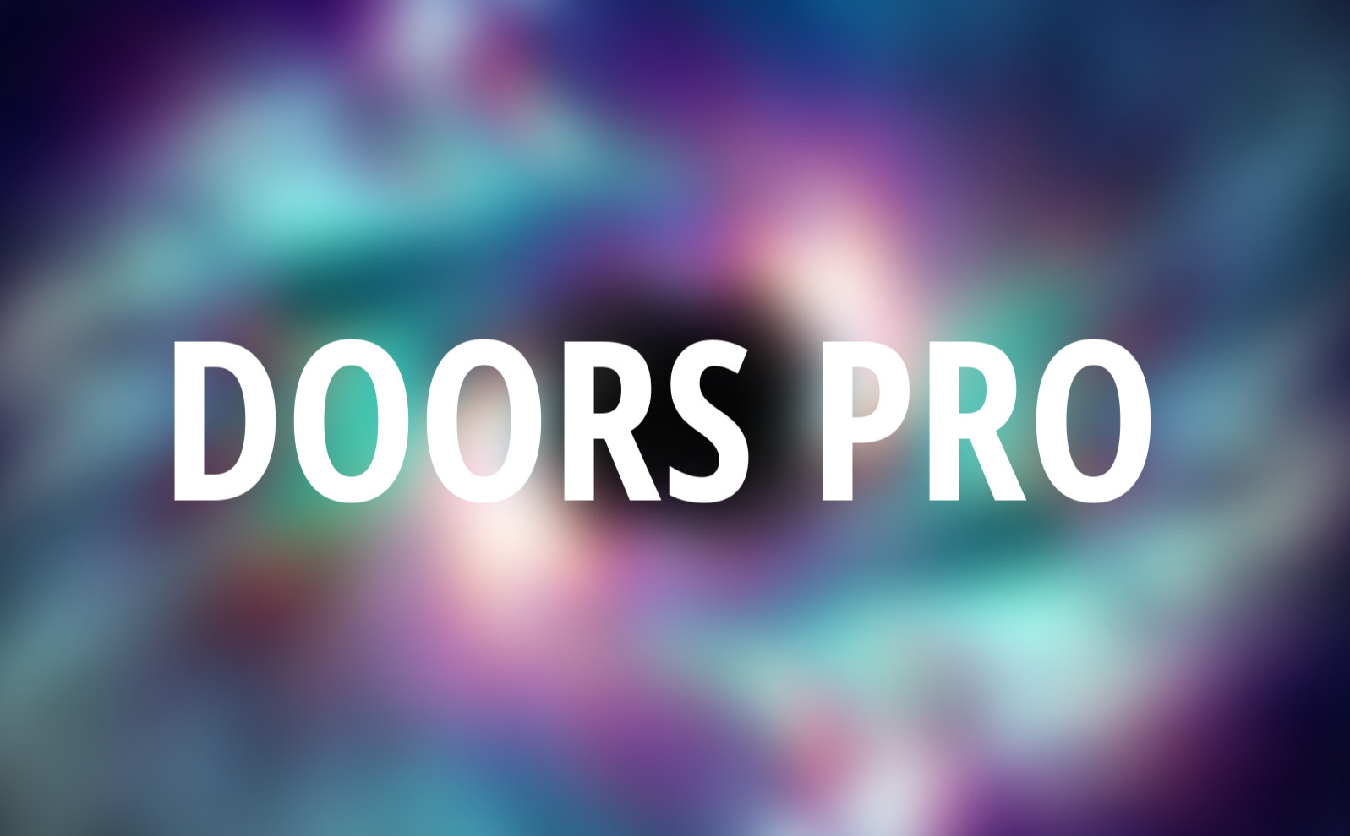

**Hello and welcome to the quick-start guide for RockStudio V2.2. First of all, we’re going to move some folders so that the icons are displayed nicely!**

1. **Create a folder called 'Editor Default Resources' and put it directly under the Assets root folder. So this would be Assets/Editor Default Resources.**
2. **Find the folder 'Icons' under Assets/Ameye/RockStudio/Icons and move that folder into the Editor Default Resources folder.**

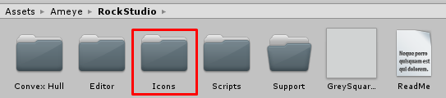

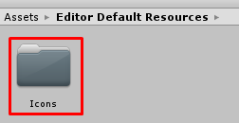

1. **Find the image 'GreySquared.png' under Assets/Ameye/RockStudio and move that file into the Editor Default Resources folder.**

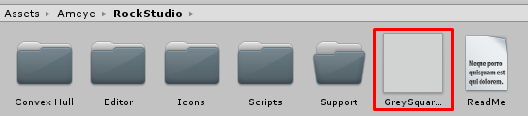

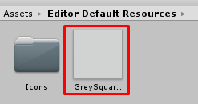

1. **Re-start Unity**

**Now let’s set-up some things so we can start making some working doors! You’ll have to do these things**

1. **Click Edit>Project Settings>Tags and Layers**
2. **Click on the little arrow next to ‘Tags’ and create a new tag by clicking on the plus icon**

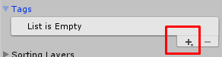

1. **Name the new tag ‘Door’**

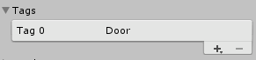

1. **Open the demo scene under Assets>Ameye>DoorsPro>Demo**
2. Make sure you set the gizmos to be visible in the game view so you can actually see the trigger zones!

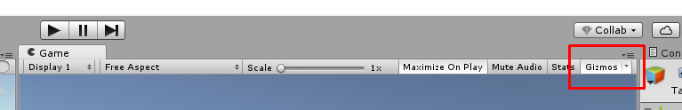

**For more information about the asset/the demo scene, check out the documentation under**

**Tools>Doors Pro>Support>Documentation**